DEVELOPMENT OF SENSORY MOTOR REFLEXES IN 2 G EXPOSED RATS

René Wubbels⁽¹⁾, Valentine Bouët⁽²⁾, Herman de Jong⁽¹⁾, Albert Gramsbergen⁽²⁾

⁽¹⁾ Vestibular Department ENT, Academic Medical Center, Amsterdam, NL
⁽²⁾ Department of Medical Physiology, University of Groningen, Groningen, NL

ABSTRACT

During gestation and early postnatal development, the animal’s size and weight rapidly increase. Within that period, gravity affects sensory and motor development. We studied age-dependent modifications of several types of motor reflexes in 5 groups of rats conceived, born and reared in hypergravity (HG; 2 g). These rats were transferred to normal gravity (NG; 1 g) at various post-natal days, and their behavioral reflexes were compared with a control group which was constantly kept under NG. HG induced a retarded development of vestibular dependent reflexes. Other types of motor behavior were not delayed.

1. INTRODUCTION
Postural control and effective execution of behavioral motor patterns depend on the existence of a previously established consistent frame of reference, together with the instantaneous input from various sensory systems. Adaptation to a new frame of reference after a change of gravity conditions, either in weightless-ness during space flight or in HG inside a centrifuge, is possible, and relies on a recalibration of sensory input and an update of motor commands.
The vestibular system plays a crucial role in both the initial establishment of this frame of reference [e.g. 9] and in the adaptation that may eventually be required. It has been shown that the vestibular sensory epithelial cells are not much affected by HG exposure [17,18]. The epithelial innervation, however, does depend on the level of gravity [8,13]. Also, the altered input from ventral descending pathways, resulting from HG exposure, affects motoneuron development [5]. It is to be expected, therefore, that HG induced neuronal changes such as these will be reflected in the animal’s motor behavior.
Previously, the effect of prolonged HG exposure on the rat’s motor behavior has been investigated at an age when development is already complete [1,2,15,16]. Also, the influence of prenatal weightlessness on motor behavior of neonatal rats has been studied [11]. In the present study, attention was focussed on the behavioral effects of HG during early pre- and postnatal development [cf. 3]. At P40, muscle tissue of these rats was procured for examination [4].

2. METHODS
Gestation and early postnatal development of rats occurred under 2g conditions inside a centrifuge [16]. Development of a control group occurred under normal gravity (N=7). Five groups of HG exposed rats were transfered to NG on different postnatal days (P5, P10, P15, P21, P27; N=7, 7, 6, 7 and 7 resp.). Behavioral tests started on the day HG rats were removed from the centrifuge and lasted until P40; NG rats were tested from P5. Six types of motor behavior were studied: I Contact-righting: time needed for a pup to turn from a supine to prone position on the floor, II Air-righting: time needed to turn from a supine to prone position during fall, III Negative geotaxis: time taken to turn from nose-down position on a tilted plane (45°) to nose-up, IV Grasp reflex: flexion of fore- and hindpaw digits at touch of a thin rod, V Forepaw grip time: suspension time when grasping a rod, VI Postural tail reflex: extension of neck and limbs when held by the tail.

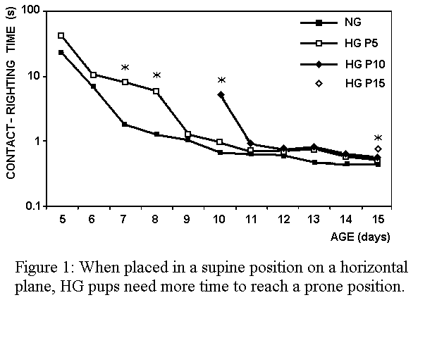
3. RESULTS
Three types of behavior (I-III) depend on directional information from the vestibular system. Our observations show that they are all delayed relative to the developmental progress of NG rats. I Contact-righting of HG rats is initially less successful (HG-P5) and takes longer to complete (Fig. 1; HG-P5, HG-P10 and HG-P15). II Air-righting of all HG groups is delayed by at least 1 day and, if performed successfully, takes more time to be completed. The average success rate of HG-P27 even remains lower for a prolonged period of time. III Negative geotaxis is initially slower in HG rats but becomes normal within a few days.
Development of the other three types of behavior is either normal (IV and VI), or appears to be advanced (V). HG exposed pups (HG-P5), for instance, initially displayed increased muscle strength (Fig. 2). Furthermore, eye opening of HG pups (HG-P5 & HG-P10) occurred 2-3 days earlier than in other HG exposed rats and controls.
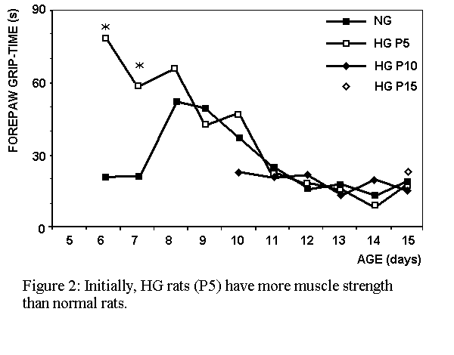
4. CONCLUSION
HG exposure delays development of reflexes and motor patterns which depend on directional information from the vestibular system (I-III); other reflexes (IV-VI) are not delayed. Apparently some developmental processes are even accelerated: We conclude that (a change of) the magnitude of the gravitational field plays a role during gestation and postnatal development of the rat, and can alter the chronological order of these processes and the relative predominance of separate sensory systems for motor activity. However, none of the observed developmental delay was irreversible, and at P40 no differences between HG exposed and NG rats remained.
The exact mechanism underlying the observed retardation requires further research because HG not only affects the vestibular system. For instance, metabolism is higher under HG (resulting in lower weight and body fat reserves [7]). Also, growth rate of the pups may be influenced by altered hormone levels. This can be either indirectly through a decreased prolactin level affecting maternal behavior [10,12], or directly through the pups’ thyroid functioning [14].
Nevertheless, our observation that vestibular dependent motor behavior is retarded and other behavior is not, strongly suggests that the vestibular system is involved. This conclusion is supported by recent studies which report that development of the vestibular system itself is delayed in hypergravity [6,8].

Animal treatment was in accordance with Dutch law, EC Council Directive (86/609/EEC; 24-11-1986), and NIH directives (publication No. 86-23, revised 1985). This research was sponsored by the European Space Agency.

REFERENCES
- Bouët V., Gahéry Y., Lacour M., Behavioural changes induced by early and long-term gravito-inertial force modification in the rat. Behav. Brain. Res. 139, 97-104, 2003.
- Bouët V., Borel L., Harlay F., Gahéry Y., Lacour M, Kinematics of treadmill locomotion in rats conceived, born, and reared in a hypergravity field (2 g). Behav. Brain. Res. 150, 207-216, 2004.
- Bouët V., Wubbels R. J., de Jong H. A. A., Gramsbergen A., Behavioural consequences of hypergravity in developing rats. Dev. Brain Res. in press, 2004.
- Bouët V., IJkema-Paassen J., Wubbels R., Gramsbergen A., Development of the locomotor system in 2 g exposed rats. J. Gravit. Physiol. 11, this issue, 2004.
- Brocard F., Clarac F., Vinay L., Gravity influences the development of inputs from the brain to lumbar motoneurons in the rat. Neuroreport 14, 1697-1700, 2003.
- Chabbert C., Brugeaud A., Lennan G., Lehouelleur J., Sans A., Electrophysiological properties of the utricular primary transducer are modified during development under hypergravity. Eur. J Neurosci. 17, 2497-2500, 2003.
- Fuller P. M., Warden C. H., Barry S. J., Fuller C. A., Effects of 2-G exposure on temperature regulation, circadian rhythms, and adiposity in UCP2/3 transgenic mice. J. Appl. Physiol. 89, 1491-1498, 2000.
- Gaboyard S., Sans A., Lehouelleur J., Differential impact of hypergravity on maturating innervation in vestibular epithelia during rat development. Dev. Brain Res. 143, 15-23, 2003.
- Geisler H. C., van der Fits I. B. M., Gramsbergen A., The effects of early vestibular deprivation on the motor development in the rat. Behav. Brain Res. 86, 89-96, 1997.
- Megory E., Oyama J., Hypergravity effects on litter size, nursing activity, prolactin, TSH, T3, and T4 in the rat. Aviat. Space Environ. Med. 55, 1129-1135, 1984.
- Ronca A. E., Alberts J. R., Effects of prenatal spaceflight on vestibular responses in neonatal rats. J Appl Physiol, 89, 2318-2324, 2000.
- Ronca A. E., Baer L. A., Daunton N. G., Wade C. E., Maternal reproductive experience enhances early postnatal outcome following gestation and birth of rats in hypergravity. Biol. Reprod. 65, 805-813, 2001.
- Ross M.D., Changes in ribbon synapses and rough endoplasmic reticulum of rat utricular macular hair cells in weightlessness. Acta Otolaryngol, 120, 490-499, 2000.
- Sajdel-Sulkowska E. M., Li G. H., Ronca A. E., Baer L. A., Sulkowski G. M., Koibuchi N., Wade C. E. Effects of hypergravity exposure on the developing central nervous system: Possible involvement of thyroid hormone. Exp. Biol. Med. 226, 790-798, 2001.
- Thullier F., Hayzoun K., Dubois M., Lestienne F., Lalonde R., Exploration and motor activity in juvenile and adult rats exposed to hypergravity at 1.8 G during development: A preliminary report. Physiol. Behav. 76, 617-622, 2002.
- Wubbels R. J., de Jong H. A. A., Vestibular-induced behaviour of rats born and raised in hypergravity. Brain Res Bull, 52, 349-356, 2000.
- Wubbels R. J., The influence of 2.5 g exposure on the morphology of rat vestibular epithelia. J. Gravit. Physiol. 9, P21-P22. 2002.
- Wubbels R. J., van Marle J., Sondag H. N. P. M., de Jong H. A. A., Effects of hypergravity on the morphological properties of the vestibular sensory epithelium. II. Life-long exposure of rats including embryogenesis. Brain Res. Bull. 58, 575-580,2002.

